

Introduction to Databases – Spring 2026 – Syllabus
Course #: 10-156-124
Section(s): 61164
Credits: 3

Welcome
I am excited to be your instructor in the first step of your path toward harnessing the power of data in technology. I look forward to helping you learn throughout the semester, and I am hopeful that together we can create an environment that contributes to your success in this course.

Hello!

My name is Brian Willem and my pronouns are he/him. I prefer you call me Brian, or Willem…but definitely not “professor”. I have been at Madison College for over 3 and a half years teaching primarily in the Data and Analytics program. I have worked for Wall Street giants, 2-person start ups and a whole lot in between. The longer I worked, the more I realized that the data behind everything I did was far more important than the software I developed around it.

How do I contact my instructor?
Instructor Name: Brian Willem
Email: bwillem@madisoncollege.edu
Student Hours and Location and/or Online Availability:
Support time available upon request. A link to my calendar is provided in Brightspace to schedule time. I encourage you to be proactive in seeking help when needed.
Phone: 608-616-1078

What will I learn in this course?
This course introduces you to relational database concepts using the Microsoft (MS) Access and MySQL database environments. You will study concepts that lead to good relational database design including an introduction to normalization. You will also practice basic SQL statements. NOTE: You should have a working knowledge of Microsoft Windows operating system (computer literacy, proficiency with a mouse, file management).

Course Competencies - https://outline.madisoncollege.edu/courses/10156124
- Describe relational database concepts
- Administer table relationships within a database
- Create queries to extract data from the database
- Explore the Normalization process regarding the design of tables in a relational database
- Utilize an Entity Relationship Diagram (ERD) when designing a database
- Setup databases using Microsoft Access and MySQL database management systems
- Setup a web application to use a database connection and display query results on a webpage

How can I be successful in this course?
This course is all about learning how to use relational databases as they relate to web and mobile applications. Our focus will be on properly designing, testing, querying, and understanding databases. I will be providing materials and activities to support your learning and together we will assess and reflect on your learning throughout the semester. This course is setup with 3 Modules. The first module takes place from Weeks 1-5. During Week 5, you will be completing your first project. This will be an excellent check-in point for us to reflect on any adjustments that need to be made for Modules 2 and 3. I look forward to helping you understand the basics of relational databases and how they fit within web and mobile software applications.
I believe our class time together is where the most growth happens.
Please come to class with your materials, having completed any reading or hands-on activities and
ready to contribute.
If you are having difficulty, please email me with your questions/concerns or to setup a time to meet either virtually or in-person.
Please also utilize the IT Guides if you are stuck and want someone to help guide you through your troubleshooting. There is a Teams workspace setup to connect virtually with the IT Guides. The link for the IT Guides is posted in Brightspace.

How will this course be structured?

This course is offered in-person, meeting on Tuesdays and Thursdays at 10:30am in room E1869. Class time will be used for instruction and collaborative practice. There may occasionally be additional time for completing lab and project assignments.

You are expected to attend class regularly and notify me if you are unable to attend. Class lectures will not be recorded.

What textbook/materials/supplies are required for this course?
We are not requiring a textbook for this course. I will include resources that are available for FREE to all Madison college students.

For other classes, keep in mind that Madison College has a textbook rental program. Each semester, you will pay a book rental supplemental fee of $7 per credit in addition to your tuition and other fees. This fee allows you to rent most of your required textbooks at no additional cost, saving you hundreds in textbook costs. It's up to you to rent your books for each of your classes. Textbook rental information can be found here https://students.madisoncollege.edu/textbook-rentals

What technology will I need to use in this class?
- Windows or Mac computer
  - Madison College can loan you a laptop for the IT Program if you need one.
- Microsoft Access
  - Can be used on school provided virtual desktops from a Windows or Mac computer
- Chrome web browser
- RedGate Data Modeler (do not sign up until given instructions on how to do so)
- Access to High-speed Internet
We will use a Brightspace course site for this class. For student support information regarding Brightspace, visit the student technical support page.
Madison College does its best to keep Brightspace up and running. If you cannot access the course, contact the student help desk.

Where can I get access to a computer and/or Wi-Fi hot spot?
You can borrow laptop computers and wi-fi hot spots for the semester, at no cost as long as you are enrolled in a class. Microsoft and antivirus software will be pre-loaded to all laptops. Complete your equipment loan request online and be sure to select IT Program to receive a higher-powered laptop.
You can call the student help desk at 608-243-4444 if you have any questions or need technology assistance. Students should bring their personal or college-loaned laptops to campus (with exceptions specific to courses and programs that have other requirements). This will ensure students can access academic resources as well as perform in-class work.

What content will we cover and when?
The course operates on three 5-week cycles. The first three weeks of each cycle introduce the learning topics for the module. The fourth week is an opportunity to apply them in activities that mimic the module project. The final week is dedicated to completing the project.
All weekly activities and module projects are described in Brightspace.

Module 1: (Weeks 1-5)
Introduction to the course. Fundamental relational database topics using Microsoft Access. Introduction to basic SQL language.

Module 2: (Weeks 6-10)
Application of database concepts to an enterprise database management system, MySQL. Introduction to database design using database diagrams and normalization. Additional use of basic SQL commands.

Module 3: (Weeks 11-16)
Application of databases. Connecting to a database with a PHP-based web page. Continuing with MySQL DBMS, Vertabelo, MySQL Workbench, and SQL.

My Commitment to You
I view my role in this course as like a manager in a workplace. My goal is to help you to succeed in learning the fundamentals of databases. When I worked in the industry, my best managers were those who helped me overcome whatever hurdles that interfered with my progress. I will do my very best to work with you in a constructive and timely manner to clear the hurdles you face in this course.
The best way to communicate with me is via email or Slack direct message. I aim to respond within 24 hours, but typically much sooner if I am awake and alert. Posting your question to the class Slack #help-me channel may lead to a faster answer to your question!
I aspire to provide personalized, constructive, and timely feedback on your assignments. I begin reviewing assignments after the due date I encourage. The initial round of grading is when I provide the most complete feedback. Assignments turned in after the initial round of grading will not receive the same level of attention. You are still able to schedule a time to meet with me to discuss any assignment, regardless of when it was submitted.

My Expectations of You
I expect you to treat this course as if it is your job. That means you will aim to complete coursework on time. You will check the official communication channels (email, Slack, Brightspace announcements) and respond within 24 hours if I have contacted you directly. You will proactively communicate with me (your “boss”) when you are falling behind or expect to miss time.
Submission of Weekly Activities: All work should be submitted as described in Brightspace using the instructions for a given activity. If you are having trouble submitting work, please email me what issue you are having and we will work together to resolve it.
If you are more than 2 weeks behind, you must setup a virtual or in-person meeting with your instructor to develop a catch-up plan. Consistent failure to schedule or attend these meetings may lead to removal from the course.

Course Feedback
Feedback will be provided in Brightspace. I encourage you to regularly check Brightspace for feedback on your submissions. In in-person classes, I may also provide verbal feedback on practice assignments.
Feedback operates in both directions! You are encouraged to tell me – without fear of any negatives – when aspects of the course and the way it is presented are hindering your learning experience.

Attendance Expectations
Our class time together is where learning happens best. Please do your best to attend every class. If you expect to miss class, please contact me both as a courtesy and to learn what you will be missing that day. Students who fail to attend 70% of class sessions may be dropped from the course, once they reach the point after which they cannot reasonably be expected to succeed.
The first five minutes of class are often the most important. Expectations for the day are set. Students arriving late for class is particularly irritating to me (sorry, I need to be honest). Please make every effort to be in the classroom at the scheduled start of class. Please avoid disrupting class if you must be late.

Homework and Preparation Expectations
Please come to class prepared to work with all resources you need in hand. I believe your time in class will be most useful if you:
- Complete all lab assignments by their due dates so that we can build on the concepts used in those labs
- Complete review of learning materials before the class in which they will be discussed so that topics are not entirely unfamiliar

Students with Disabilities (ADA Statement) and Title IX Pregnancy and Parenting Requirements
Madison College is committed to empowering students with disabilities, ensuring equal access to all academic programs and activities. To receive reasonable accommodations for your disability, you must contact Disability Resource Services (DRS). If approved, DRS will provide you with an accommodation plan. You can submit a request for services at the DRS webpage. You can contact the office anytime at 608-246-6716 or via email. If you have an accommodation plan, please share it with me as soon as possible. If you believe your accommodations are not being met, please let me or DRS know as soon as possible.
According to Title IX of the Education Amendments of 1972, students must be allowed to take time off school for pregnancy, childbirth, miscarriage, abortion, and recovery for as long as their doctor says is medically necessary. Students with pregnancy-related conditions should submit the Student Pregnancy Accommodation Request form to make a request for modifications.

Artificial Intelligence (AI) Policy
You are responsible for all of the work you submit in this course. Your submitted work should showcase your understanding of the material. I discourage the use of AI in this course as any output it creates must be reviewed and understood prior to any submission. Misuse and overuse of AI could prevent you from properly learning the skills needed to meet the objectives of this course.
All submitted projects are expected to be produced by the student themselves. You are responsible for the work you submit and may be asked to explain it at any time.

Late Assignment and Make-up Policies
I do not deduct grades for late work, however, keeping up with the weekly work is by far the best way to succeed in this class. If you are a few days behind here or there, I think you will be able to catch up, but if you are regularly getting behind, then eventually it will be difficult to complete all of the necessary work to succeed in this class. I want to help you succeed, so please reach out to me with any concerns you have or obstacles you are facing.
Submission of Assignments
All assignments should be submitted in Brightspace as described in each assignment’s instructions.

Syllabus Changes
I may modify the syllabus or schedule with reasonable notice to you. Look for an Announcement in Brightspace.

How will my performance be assessed in this course?
All 3 projects must be completed at a satisfactory (Met) level to get at least a C in this course.
To earn a B in this course, in addition to the 3 Projects, 3 of the Thought Exercises and 1 of the Module Reflections must be completed satisfactorily.
To earn an A in this course, in addition to the 3 Projects, 4 of the Thought Exercises and 2 of the Module Reflections must be completed satisfactorily.
To earn a D in this course, 2 of the 3 projects must be completed at a satisfactory level. Note that a D grade will not satisfy IT Associate Degree program graduation requirements.
*If you must fix any of your submissions, please see the feedback provided in each submission for any requirements that must be met, such as first completing specific Practice Activities before resubmitting a project.

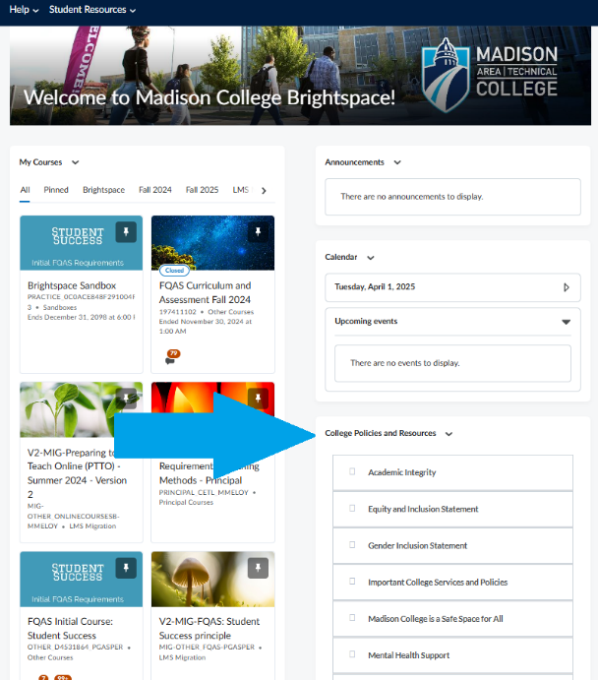
Where can I find other college policies and resources that I should be aware of?
You can easily access important college policies and resources on the Brightspace Home Page in the "College Policies and Resources" section on the right side of the page. This section includes essential information like the Academic Integrity and Equity and Inclusion Statements, Gender Inclusion Statement, Mental Health Support, Laptop and Hot Spot Loaner Program, Students with Disabilities (ADA Statement), Title IX Pregnancy and Parenting Requirements, and information about campus closure due to weather or emergencies. These resources are available to help support your success throughout the semester.

